**OOP ASSIGNMENT # 01**



**Fall 2022**

**CSE-208 OBJECT ORIENTED PROGRAMMING**

**Submitted by: Ali Asghar**

**Registration No.: 21PWCSE2059**

**Section: C**

**“On my honor, as student of University of Engineering and Technology, I have neither given nor received unauthorized assistance on this academic work.”**

**Submitted to:**

**Dr.Nasrumminallah**

**DATED: 19 / OCT / 2022**

**Department of Computer Systems Engineering**

**University of Engineering and Technology, Peshawar**

**TASK 1**

**CODE:**

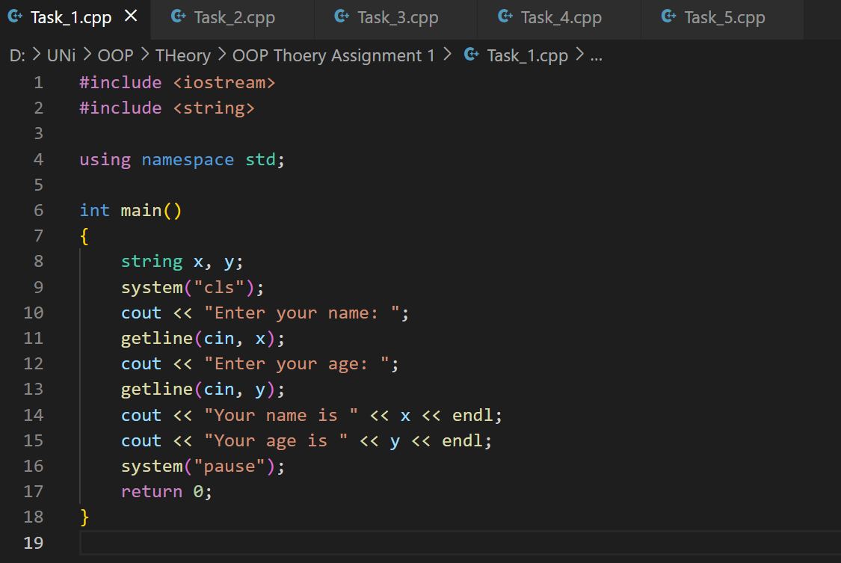

**OUTPUT:**

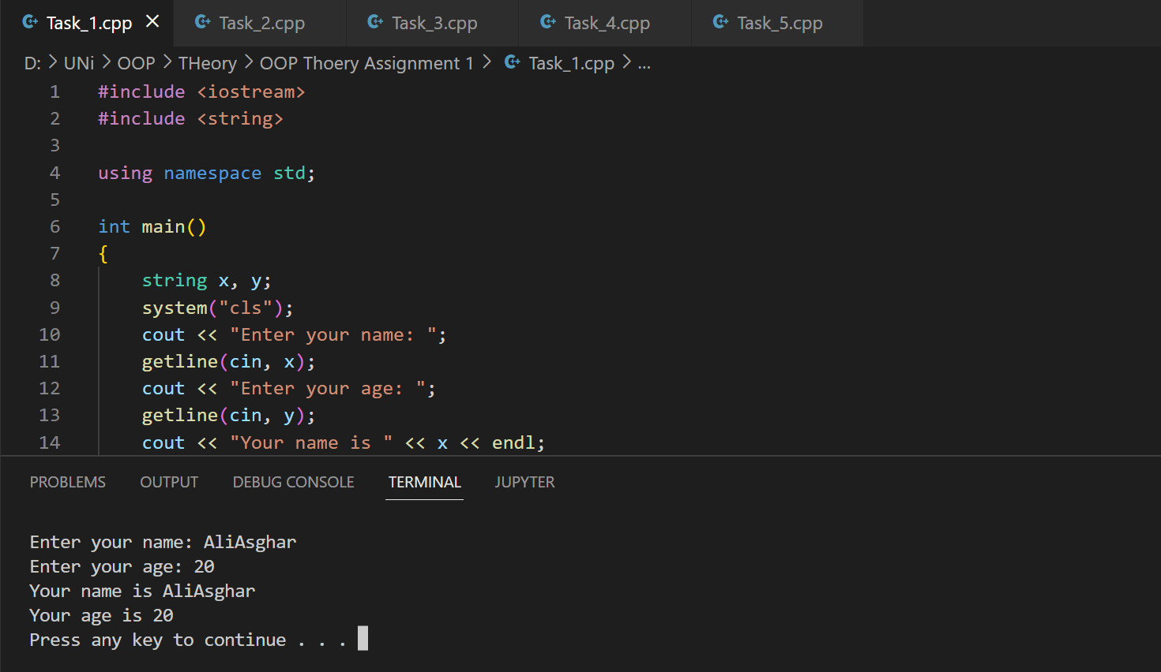

**TASK 2**

**CODE:**

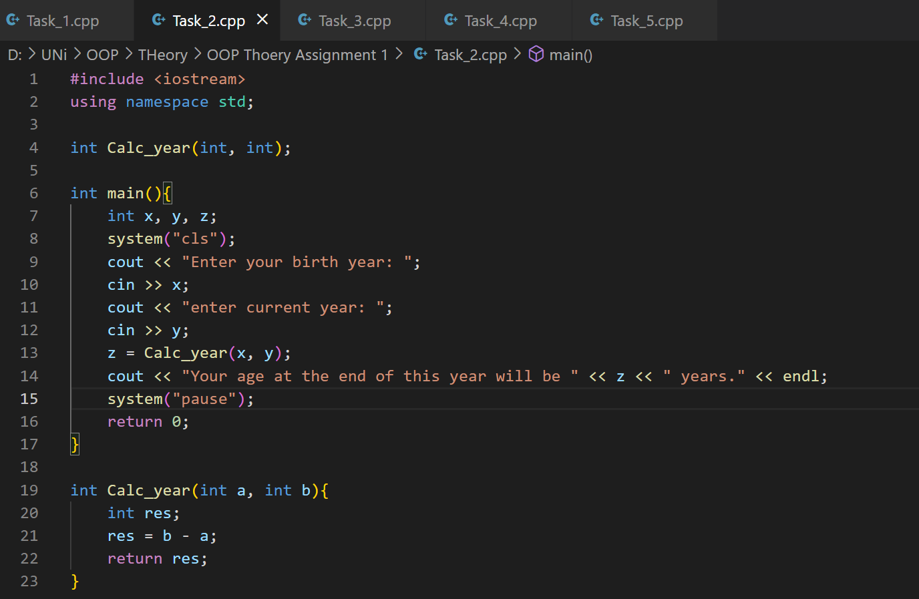

**OUTPUT:**

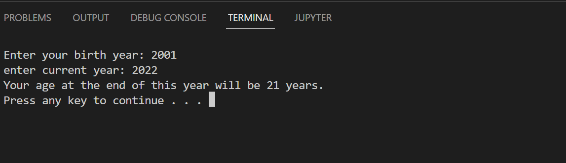

**TASK 3**

**CODE:**

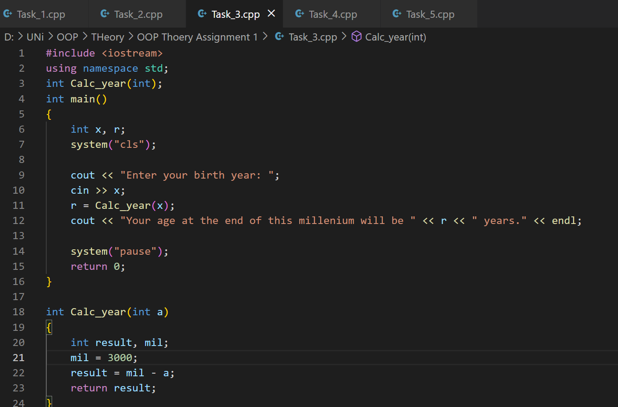

**OUTPUT:**

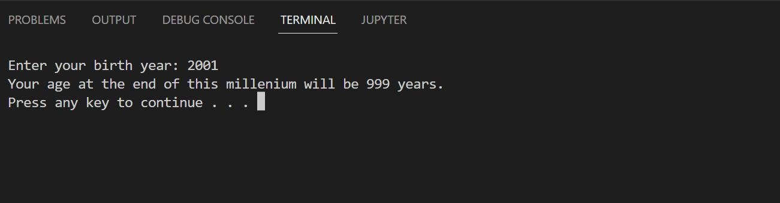

**TASK 4**

**CODE:**

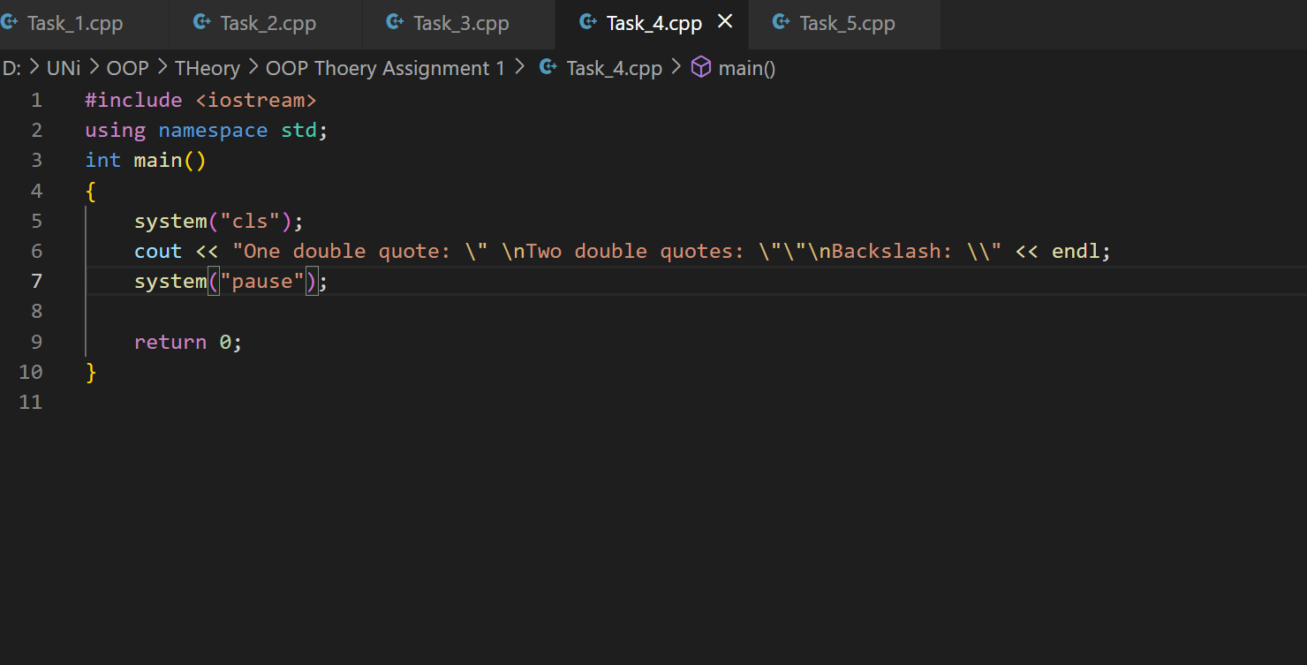

**OUTPUT:**

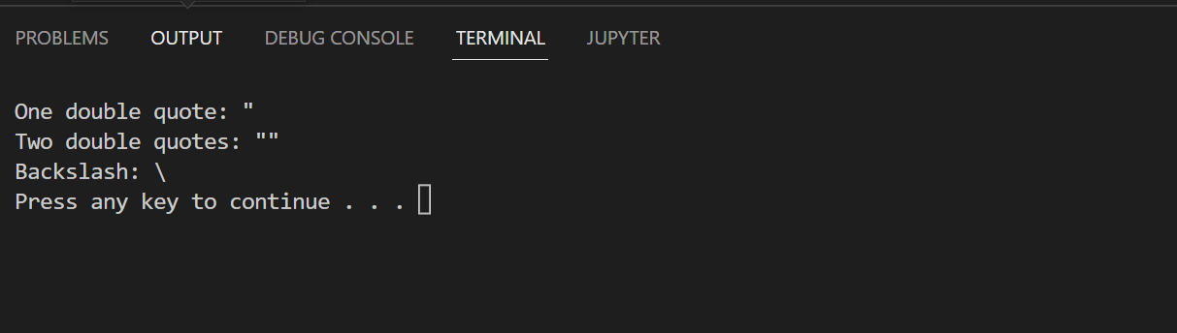

**TASK 5**

**CODE:**

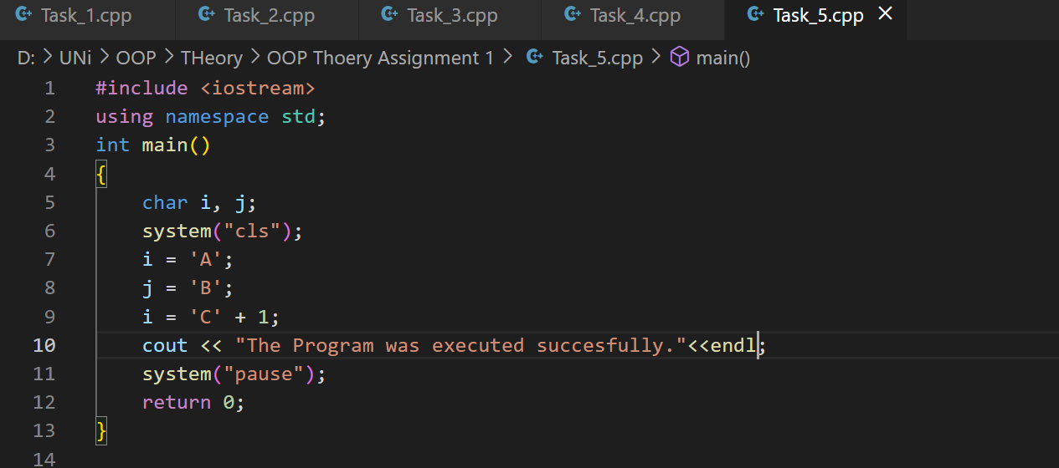

**OUTPUT:**

